**Features of Eramba – Organization (Legal Constrains)**

To add new liabilities, go to organization on left side panel and select liabilties

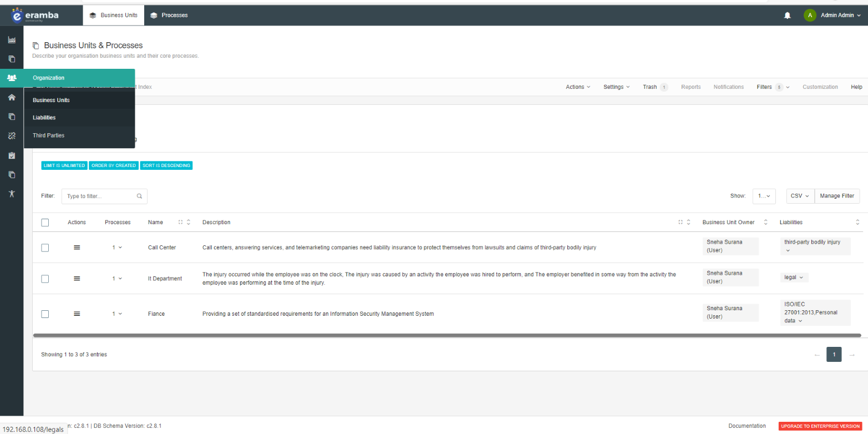

The liabilities are added

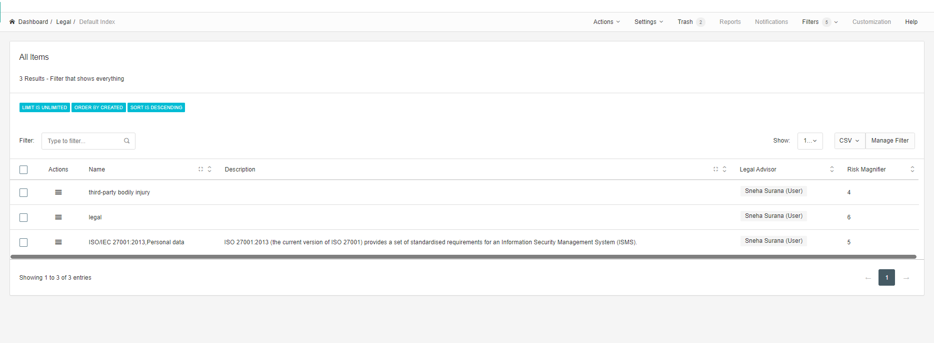

To add a new one go on dashboard and add a new



Add legal constraints like I added ISO 9001: 2015

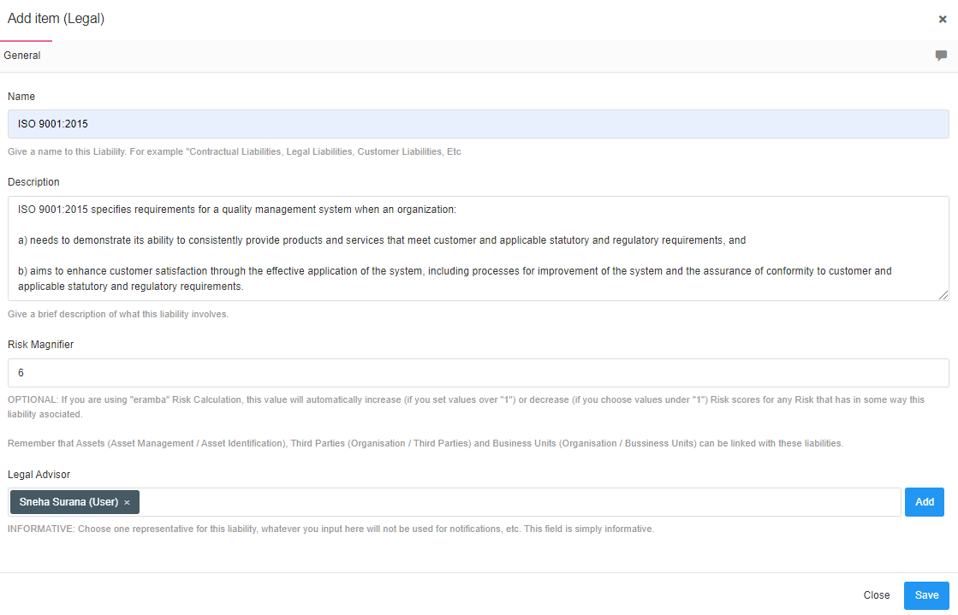

Now it is been added

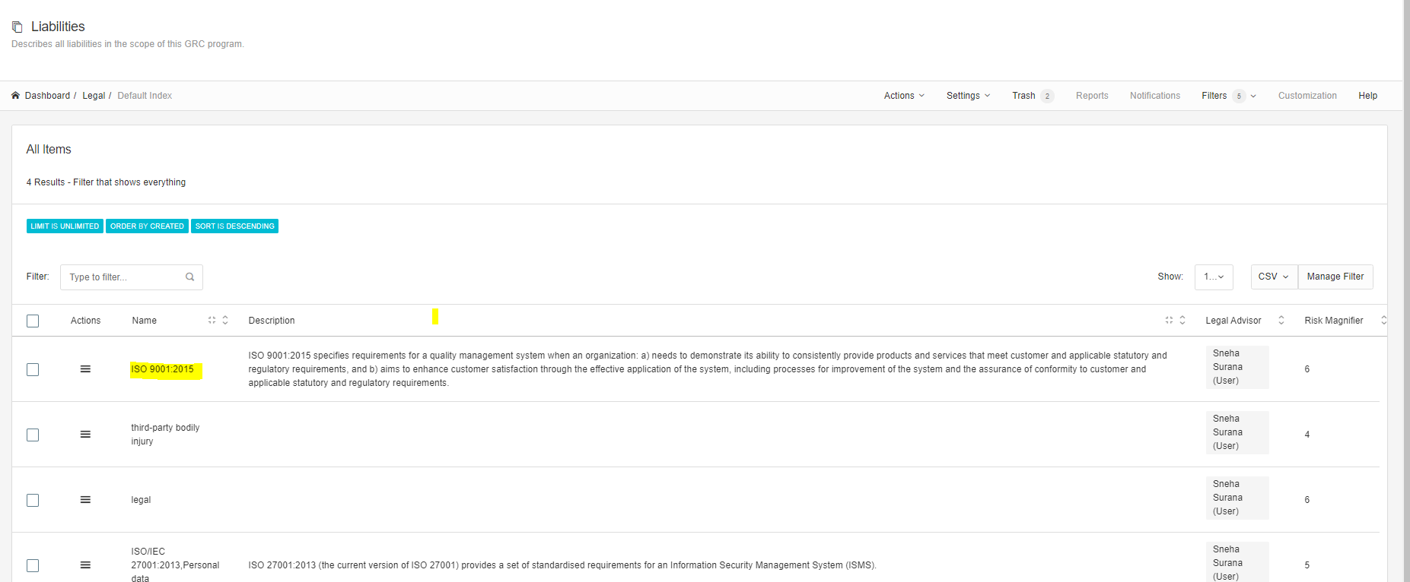

To edit the liabilities select the liabilities select the filter and click in bulk edit

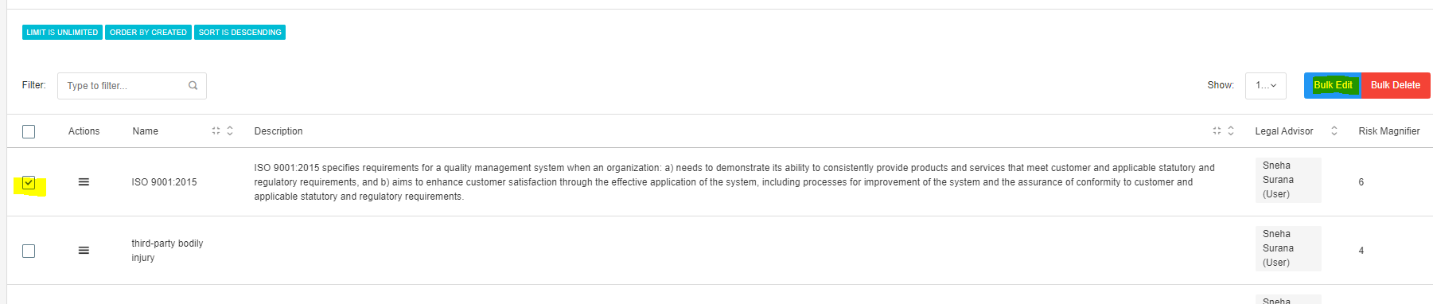

A window will appear in which you have to select a parameter you want to change and select replace



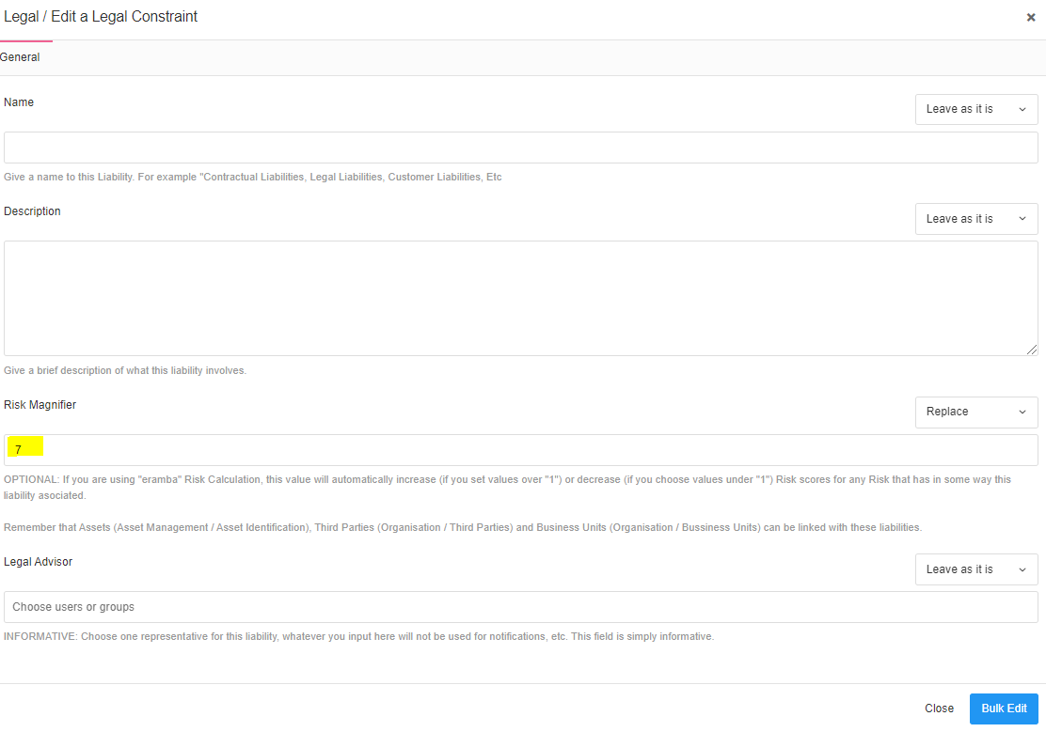

Click on Bulk edit

Earlier risk magnifier was 6 now it is 7

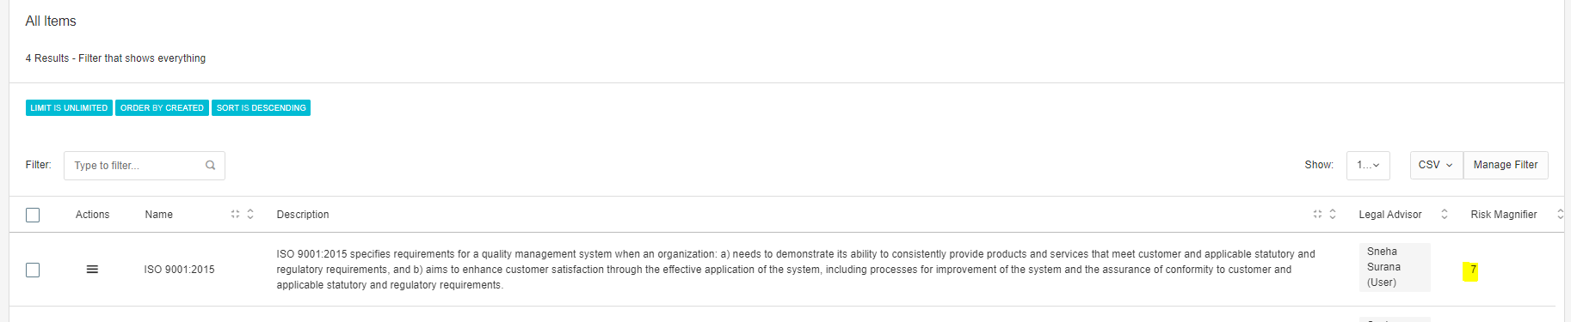

**Feature of Eramba – Organization (Third Parties)**

Go to left panel and click on organization and select Third party option

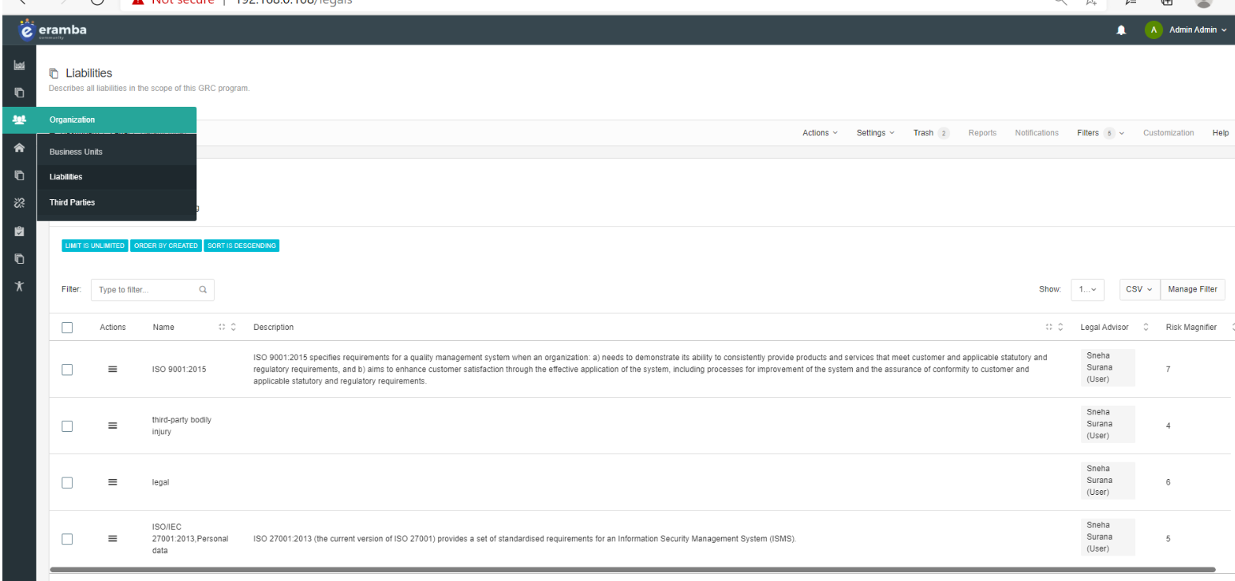

A window like this appear

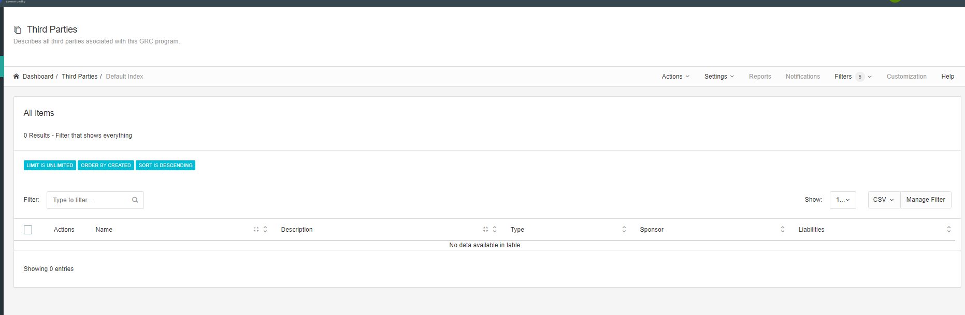

Since it is empty we need to add a new third party click on add button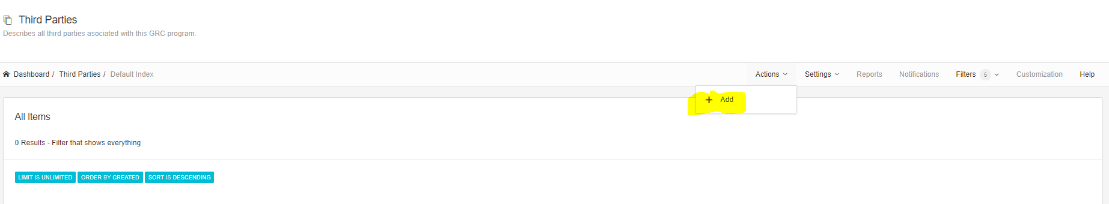

Fill the details and add a libilty

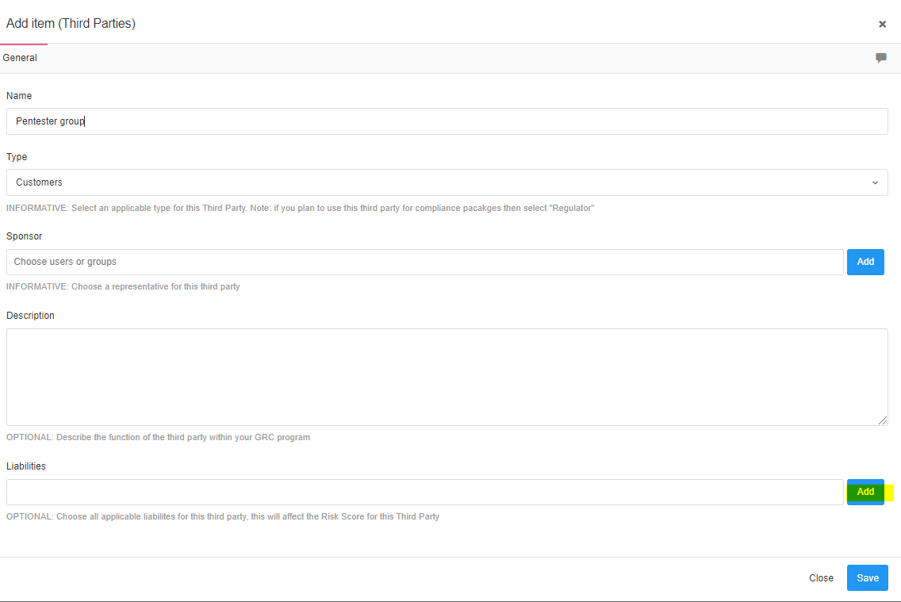

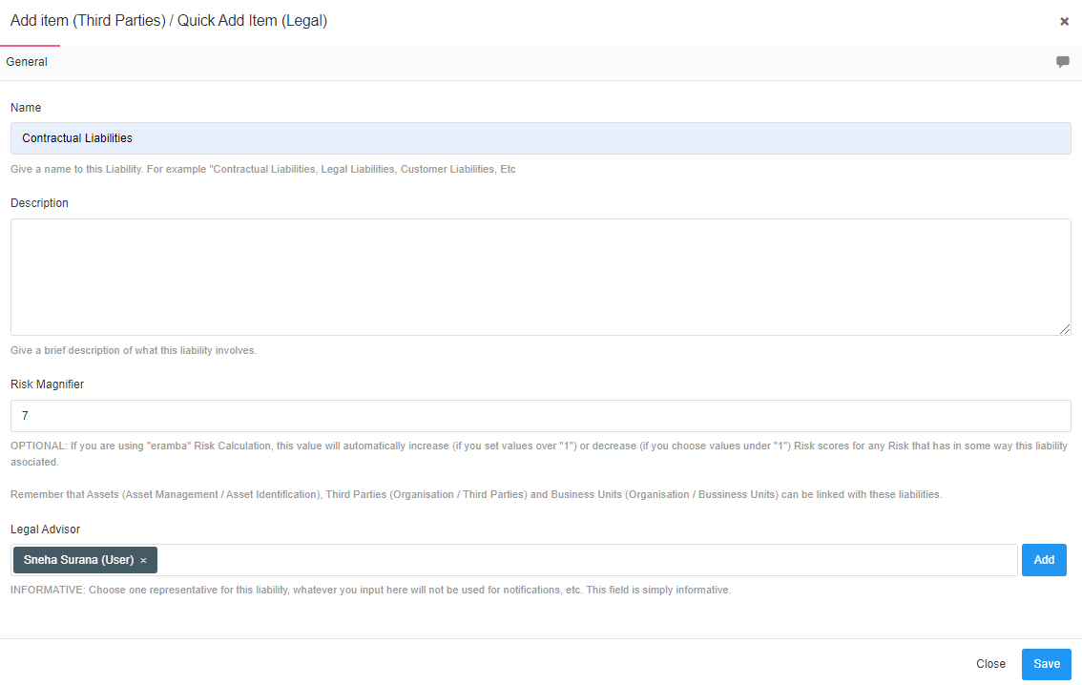

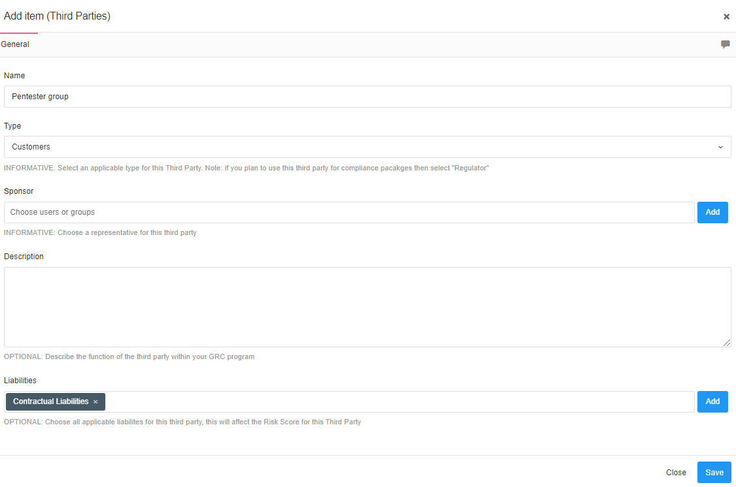

Now save it and list get updated

